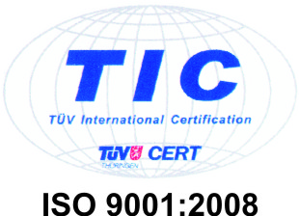

LETTER OF INTENT

It is our pleasure to present our company Limoplast d.o.o. located in the northeastern part of Bosnia and Herezegovina, engaged in the production of steel structures, special truck trailers, sheet metal and facade work, roof profiled sheets, industrial containers for waste disposal, PVC and Aluminum windows and doors (Kömmerling and Schüco), garage and sectional doors, INOX equipment and accessories and other related activities.

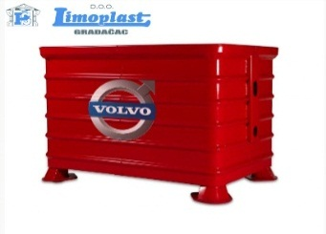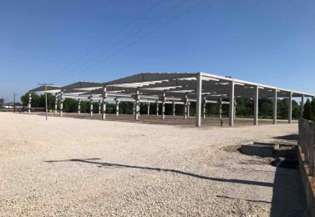

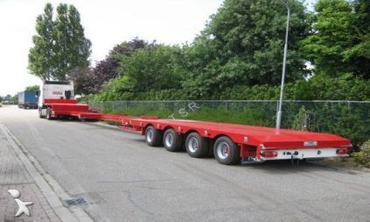

Our company is also engaded in steel processing, processing 1300 tons annualy.

We will present only some of the many machines that are used in our production plants:

Laser: Prima Platino 1530 4 kW, 1500x3000mm

Laser: Bystronic BTL 4000, 2500x6000mm

Flow: WMC 4020 DWJ, 2000x4000mm

Press: Bystronic PR2000 KN,4100mm

Press: Beyeler RT 80 KN, 1550m

Robot for welding: Limat RT 280-6

The advantage of our company is the proximity of border crossings with Croatia and Serbia, which allows us a high punctual delivery rate for European end customers. We achieve high quality standards through careful selection of our suppliers and constant monitoring from production to receipt in our warehouse.

Our goal is to be recognizable on the market and we strive to monitor the constant development and progress of technology, which we regularly confirm with new services and expand our product offerings.

For all our products we can provide a quality certificates ISO 9001: 2015, EN ISO 3834-3:2005,

DIN EN 1090, EXC4, EN ISO 3834-2, ISO 14001:2015, ISO 50001:2011 according to European Union standards.

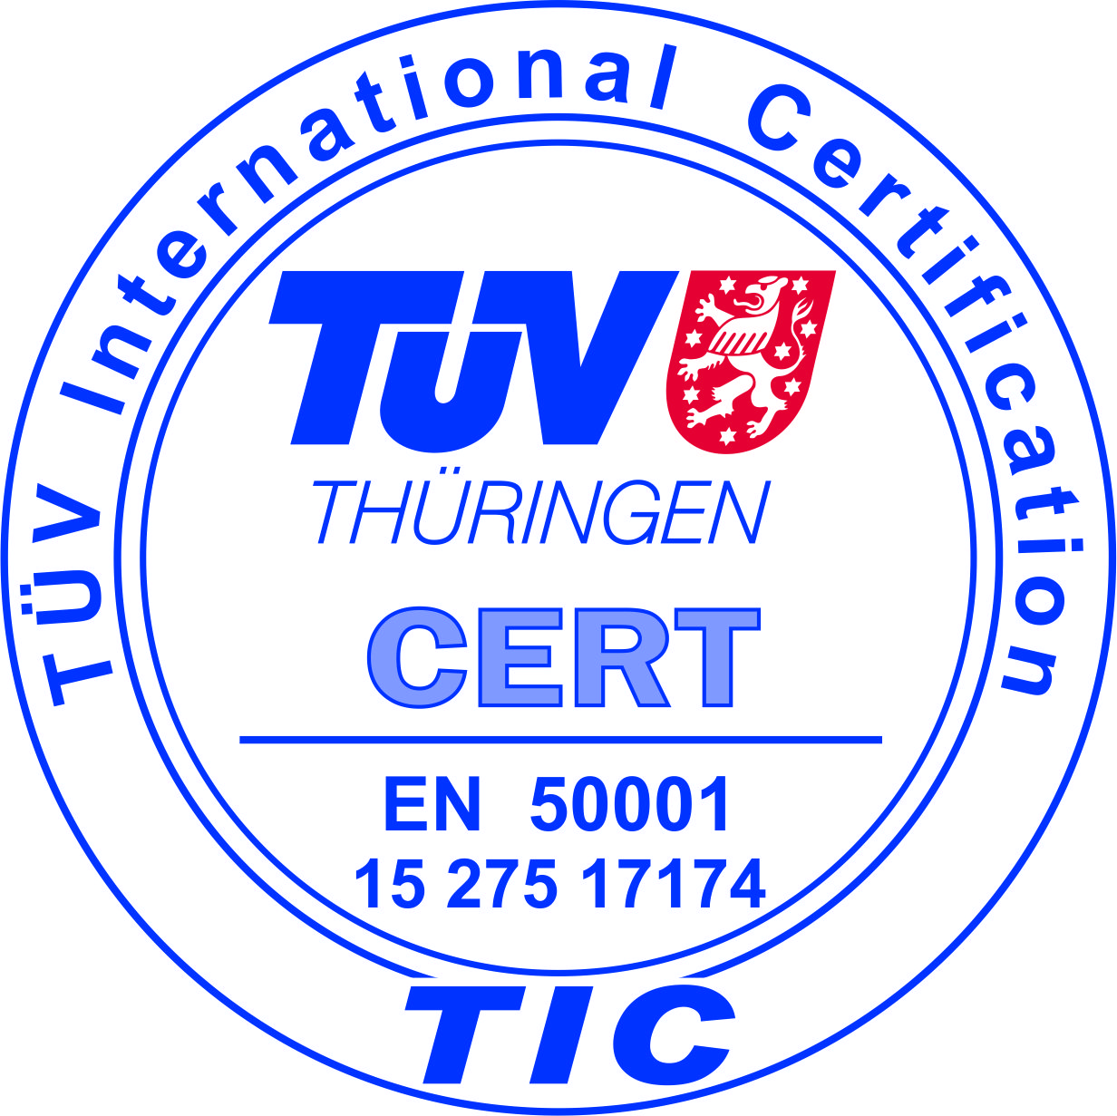 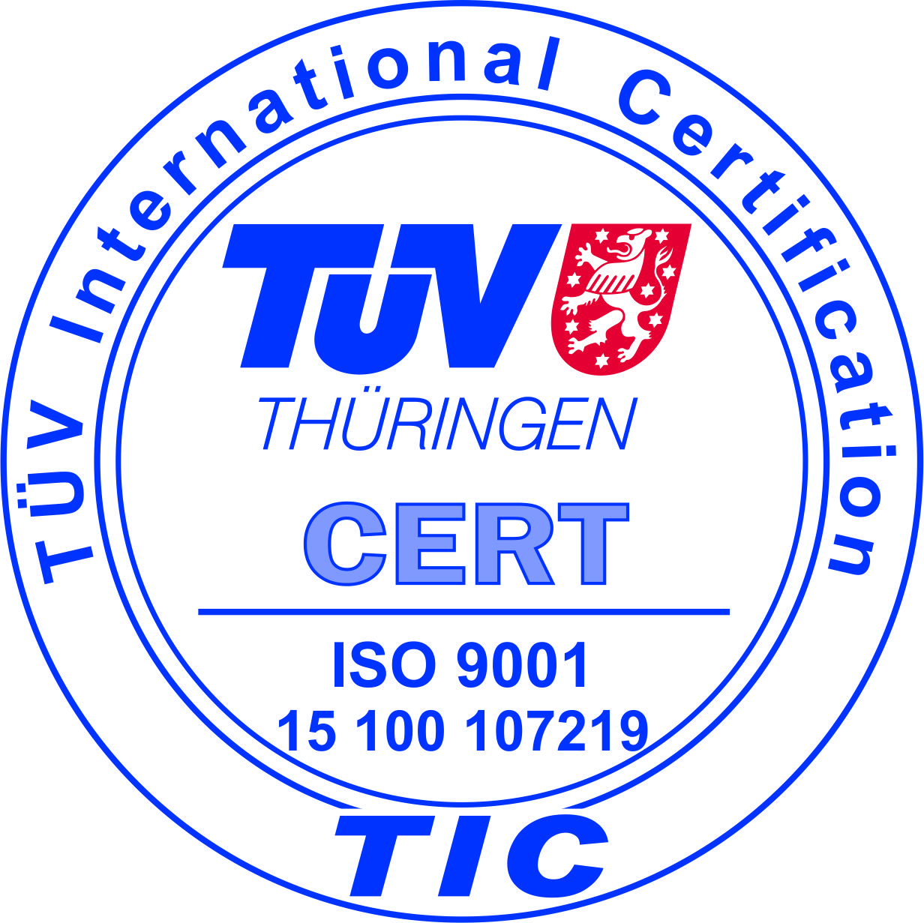 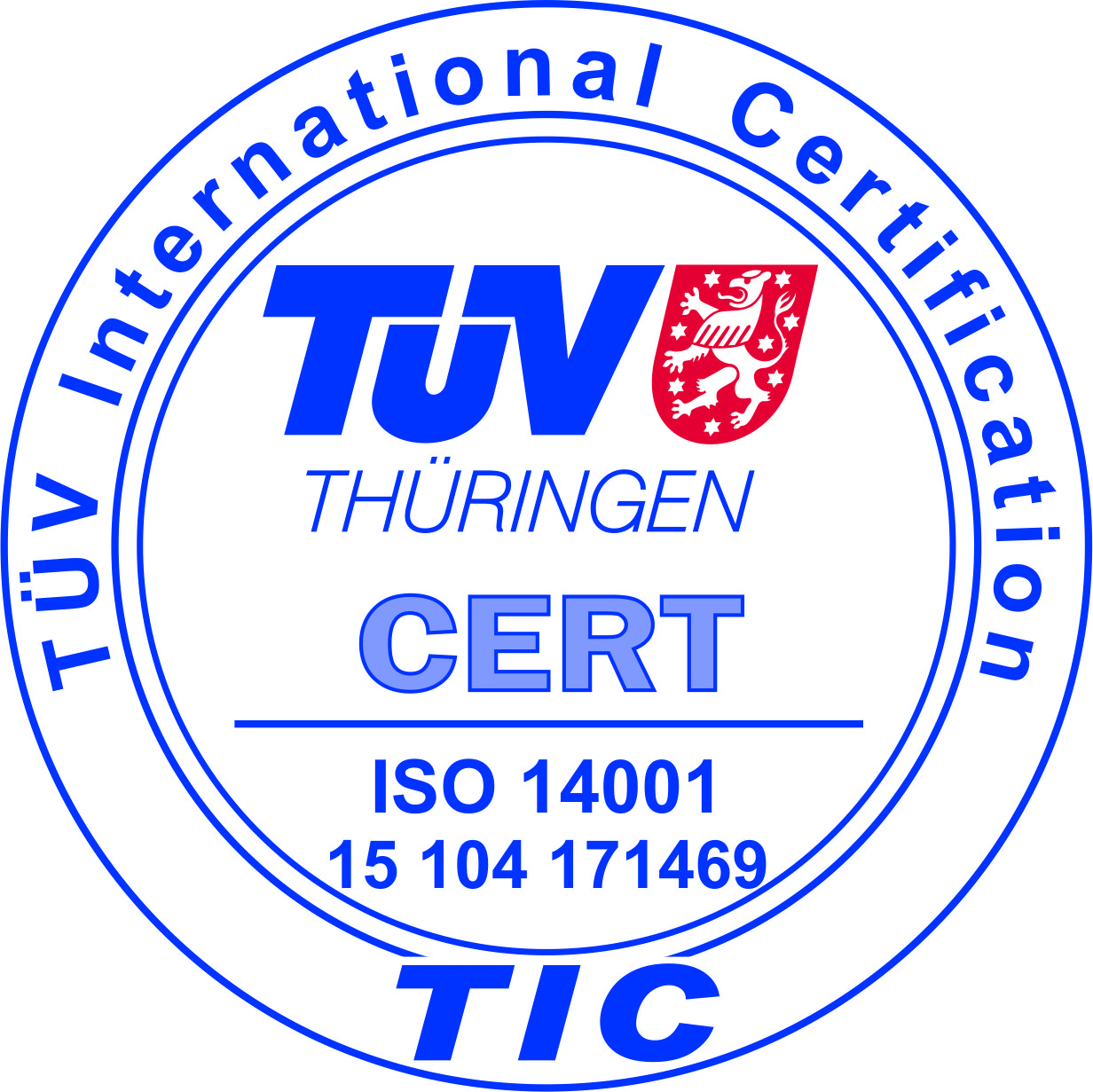

The chosen strategy ensured success with the constant development and growth of the company. Currently we employ 70 highly skilled workers in several different or related professions from the range of our jobs.

Our products are a real proof that excellent quality does not have to be expensive and that satisfied customers are the best measure of success.

If you are interested in further information, we are at your disposal.

We look forward to your reply.

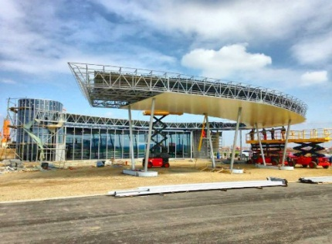 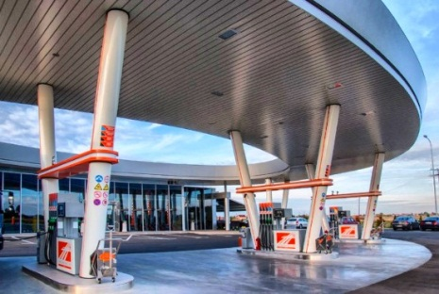

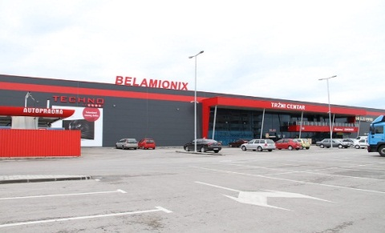 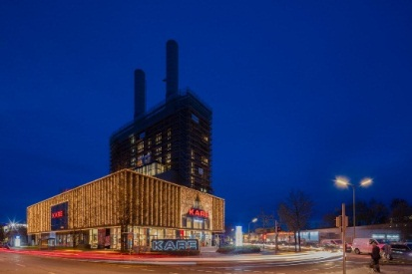

More information about our company Limoplast d.o.o., can be found on the

website <http://limoplast.com/?lang=en> , or contact by e-mail: [info@limoplast.com](mailto:info@limoplast.com);

by telephone: +387 35 817 096.